**Project Title: Bank Loan Performance Analysis**

**Data Cleaning:**

**Replace missing values (null) in the 'emp_length' column of the "BorrowerDetails" table with '0 year'.**

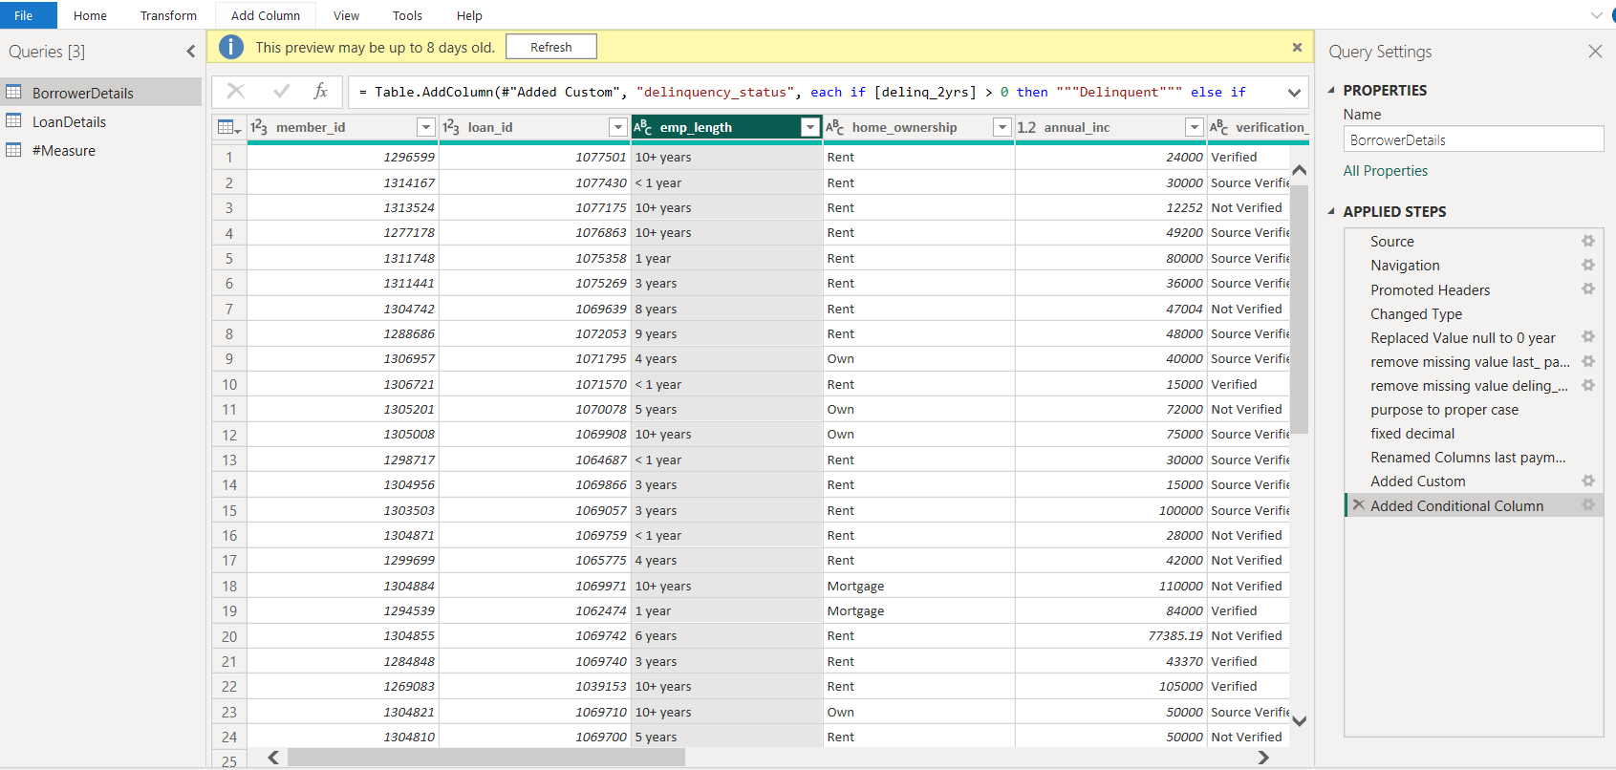

**Remove rows with missing values in the 'last_pymnt_d' and 'delinq_2yrs' columns.**

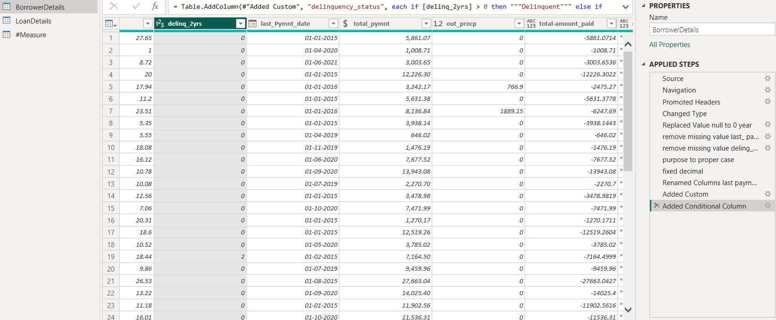

**Remove duplicate rows in the 'id' column of the "LoanDetails" table.**

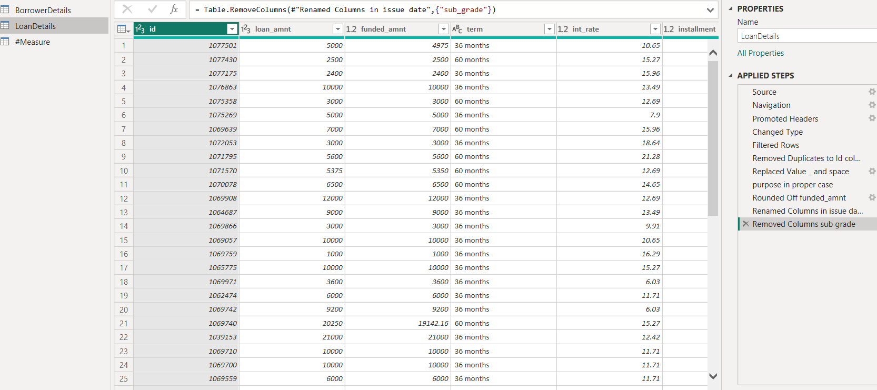

**Dealing with Inconsistencies:**

**Ensure words in the 'purpose' column are separated by spaces instead of**

**underscores (e.g., "credit card" instead of "credit_card").**

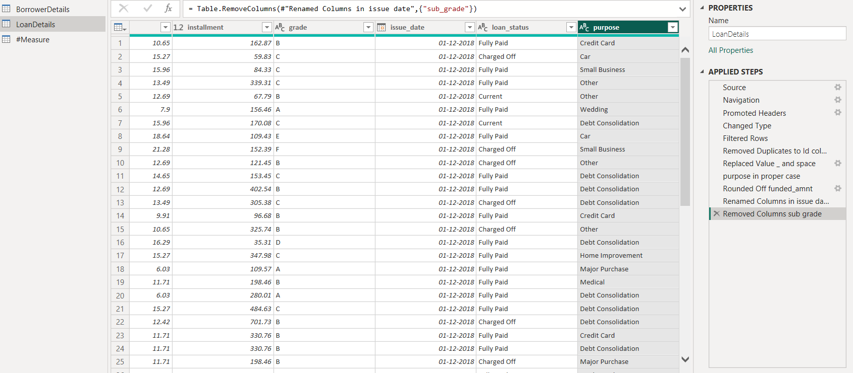

**Format the 'purpose' and 'home_ownership' columns to proper case.**

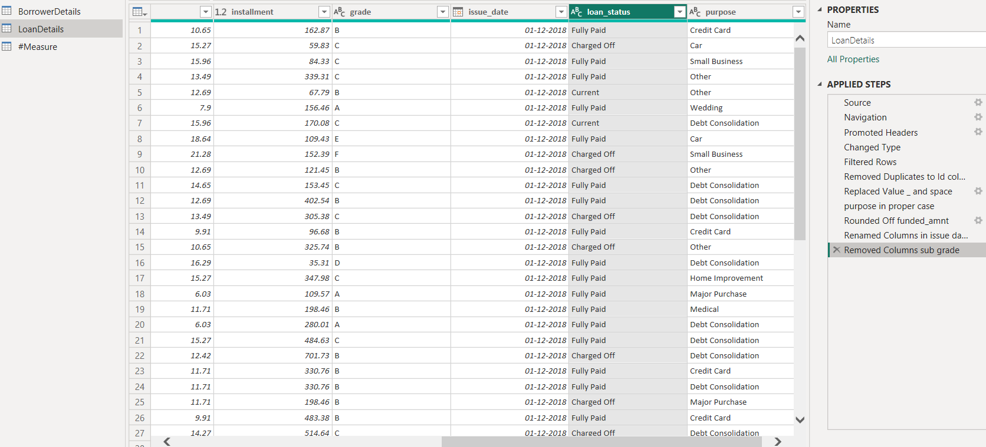

**Data Transformation:**

**Column Transformation:**

**➢ Change the data type of the 'total_pymnt' column to 'Fixed decimal number'.**

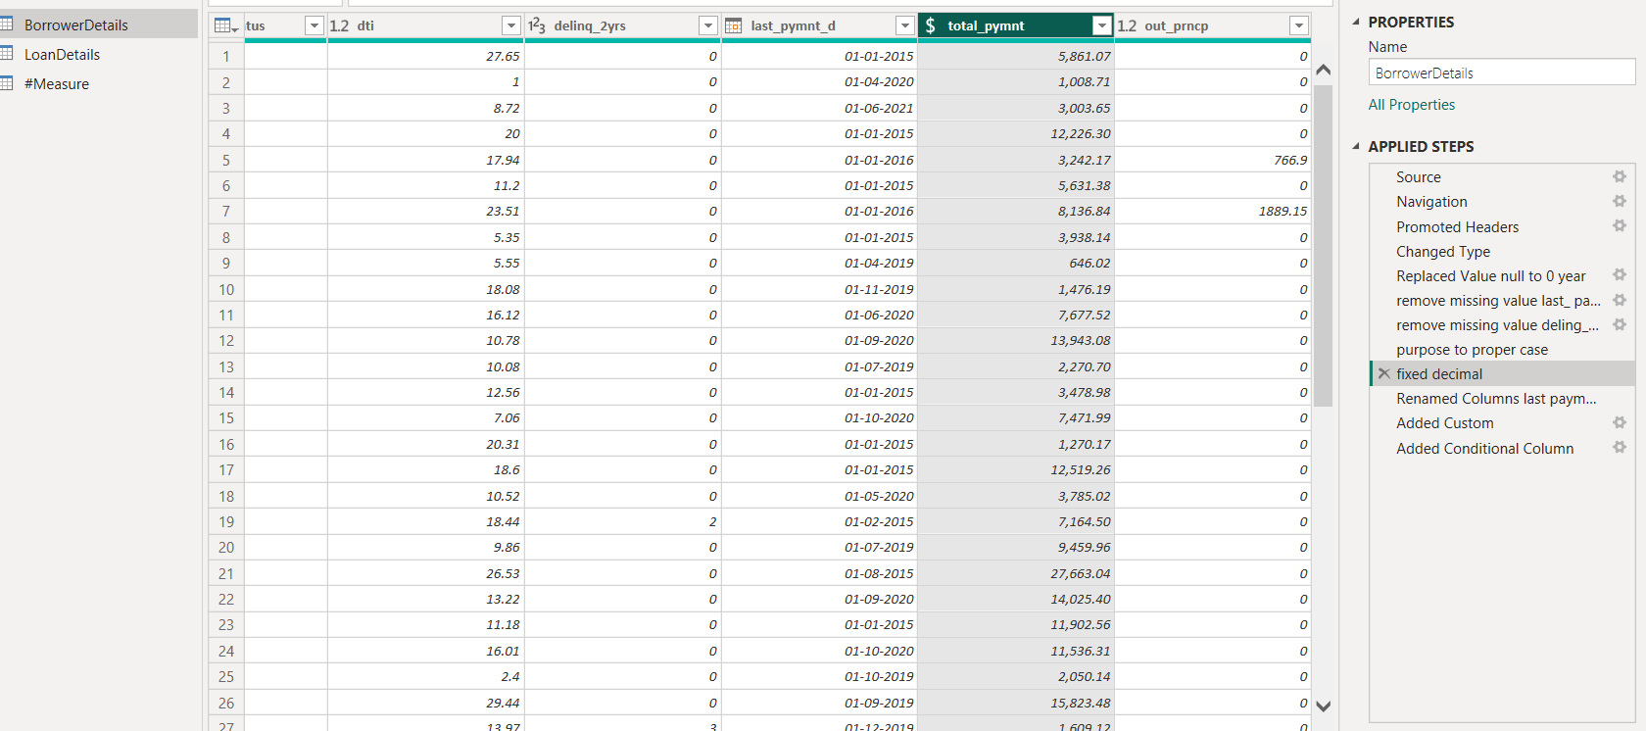

**Round off the numbers in the 'funded_amnt' column to 2 decimal places.**

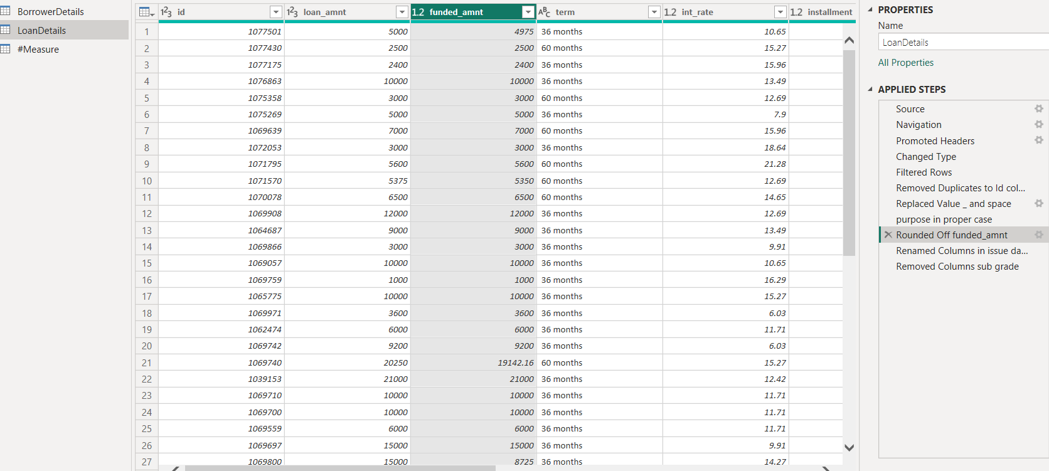

**Column Renaming:**

**Rename the column 'issue_d' to 'issue_date'.**

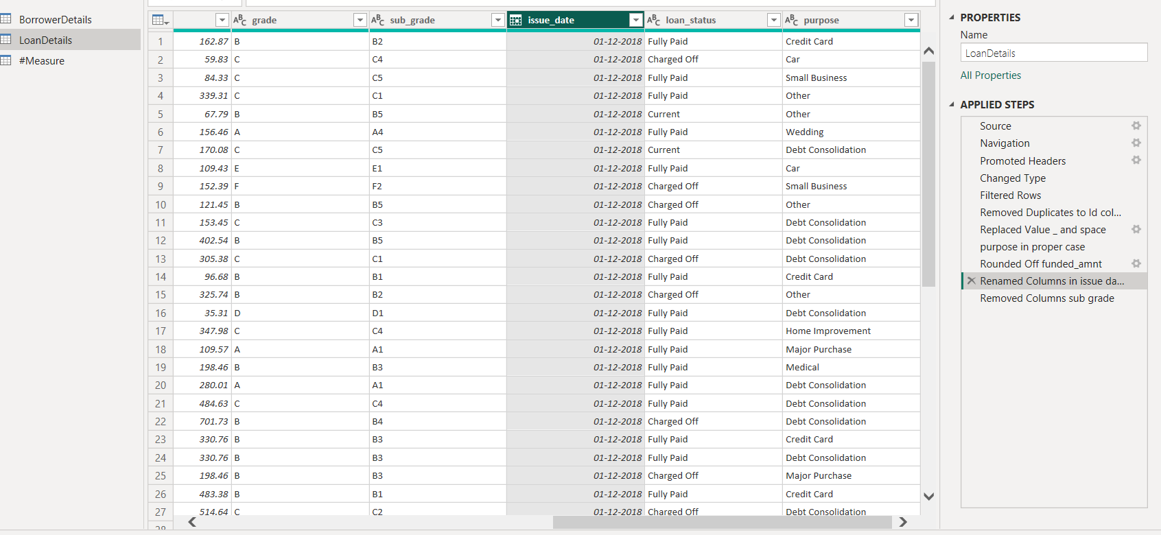

**Rename the column 'last_pymnt_d' to 'last_pymnt_date'.**

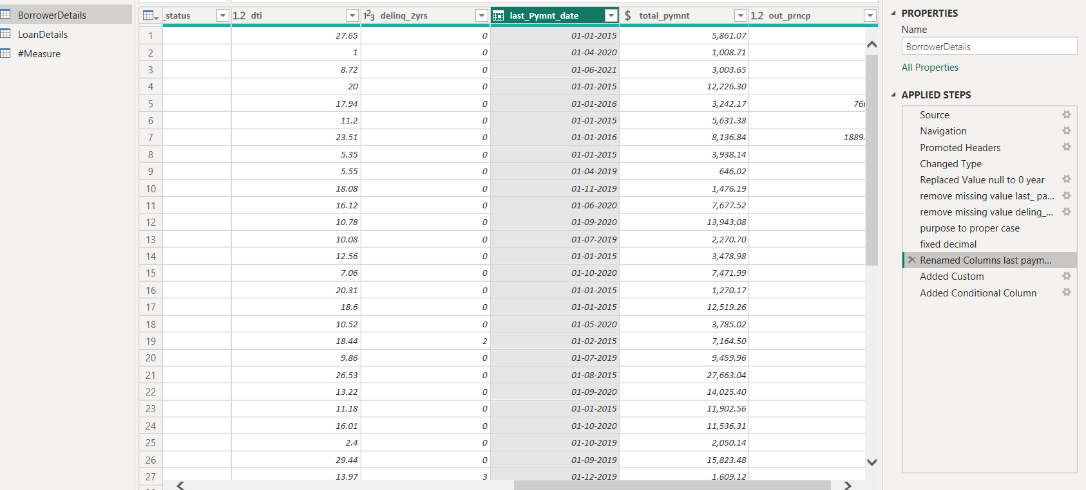

**Creating New Columns:**

**Create a new custom column named 'total_amount_paid' to calculate the total amount paid by each borrower by subtracting 'out_prncp' from 'total_pymnt'.**

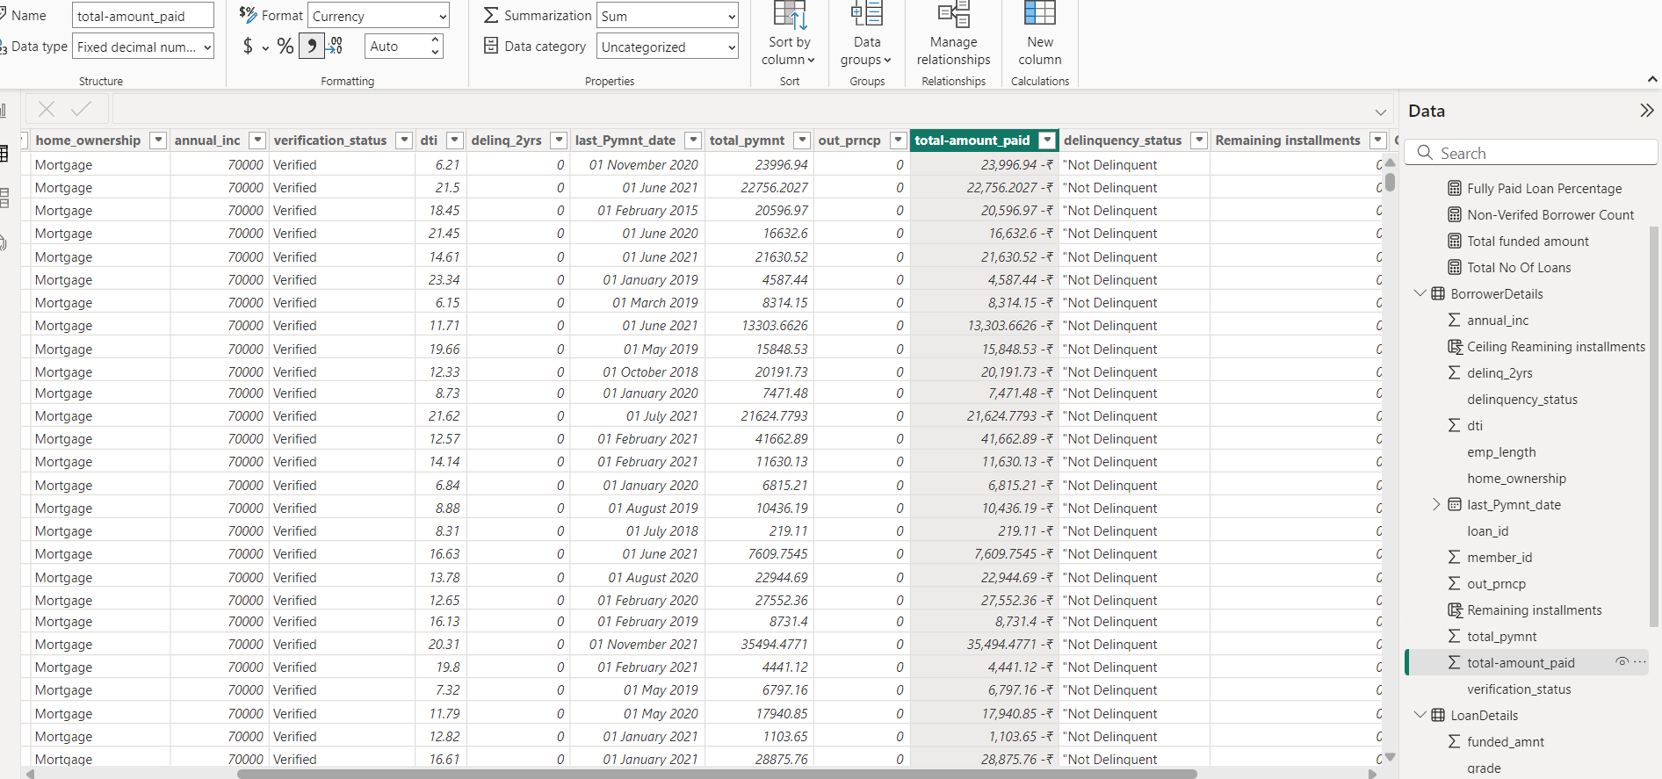

**Add a new conditional column named 'delinquency_status' to identify if the**

**borrower has any delinquencies. If the number of delinquencies in 'delinq_2yrs' is greater than 0, the status should be "Delinquent", otherwise "Not Delinquent".**

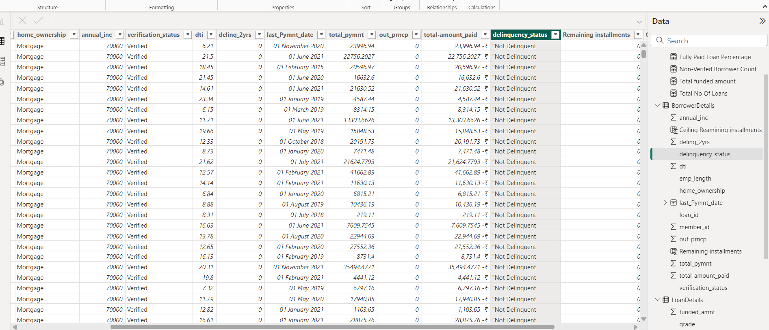

**Column Dropping:**

**Remove the 'sub_grade' column as that does not significantly contribute to the analysis.**

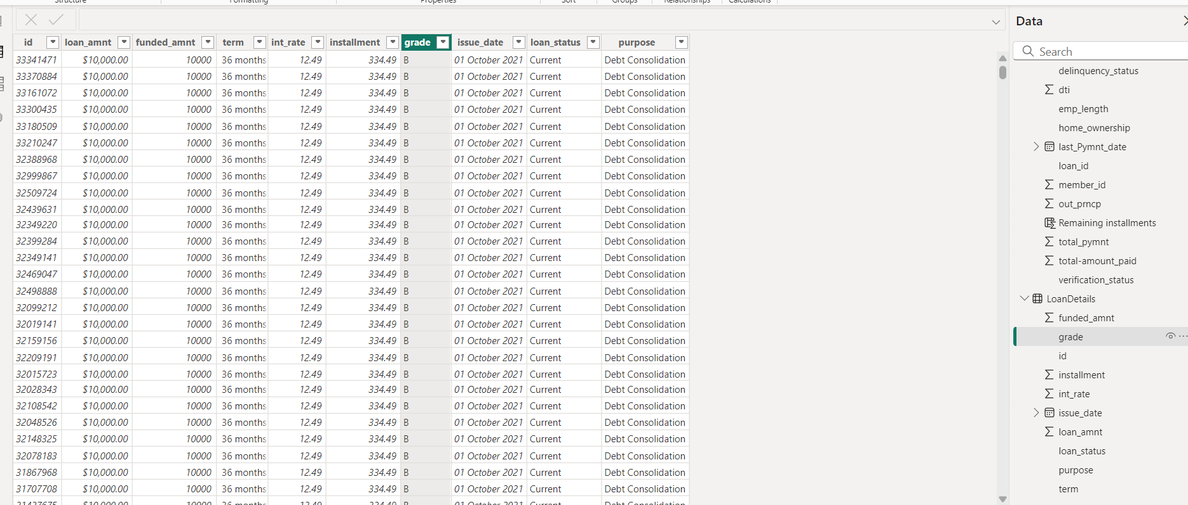

**Data Modeling:**

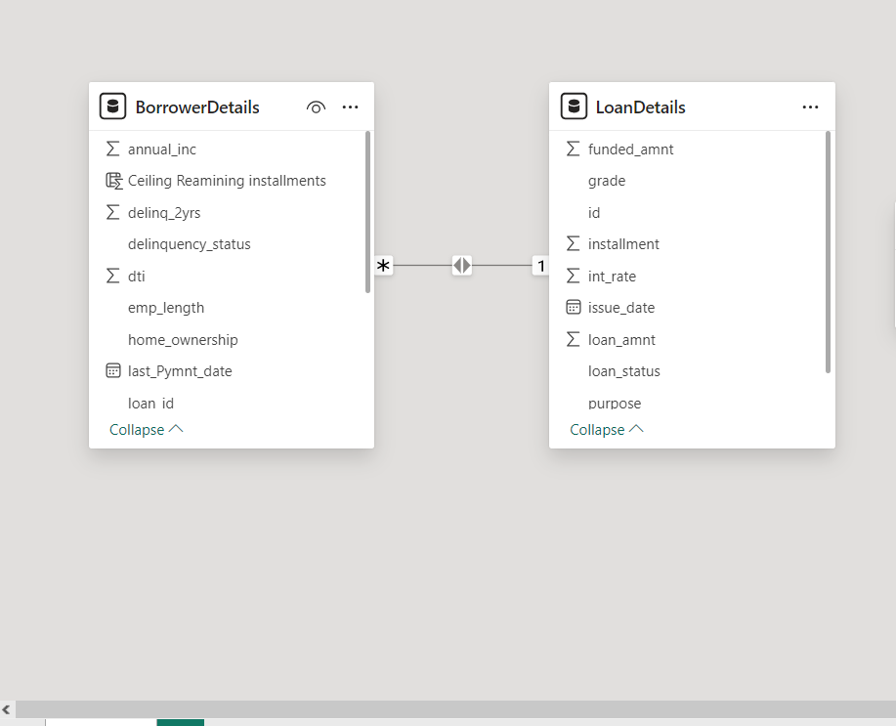

**Creating Measures and Calculated Columns using DAX**

**Create a new calculated column named 'remaining_installments' using DAX in the"BorrowerDetails" table to calculate the number of remaining installments by dividing the remaining principal amount ('out_prncp') by the monthly installment amount ('installment') and round up the result using the CEILING() function to account for any partial payments.**

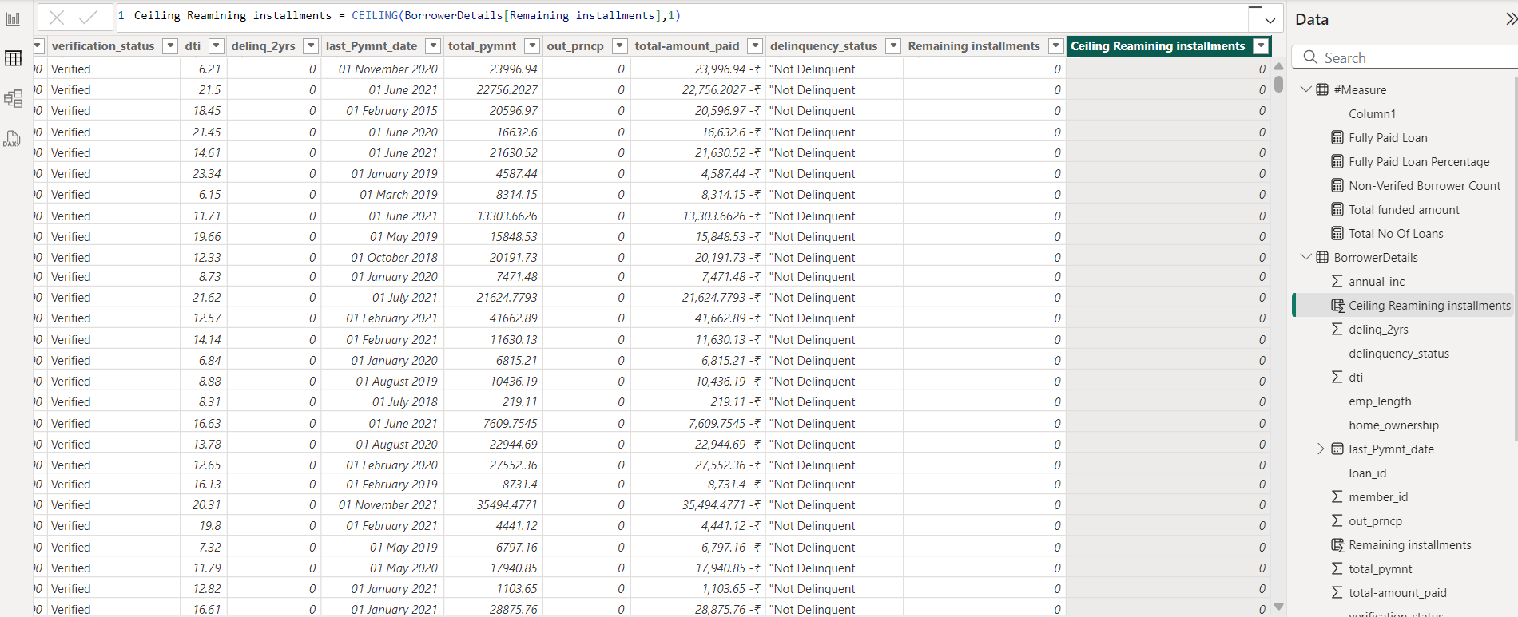

**Create a measure named 'Non-Verified Borrowers Count' using DAX to count the number of loans that have been 'Not Verified'.**



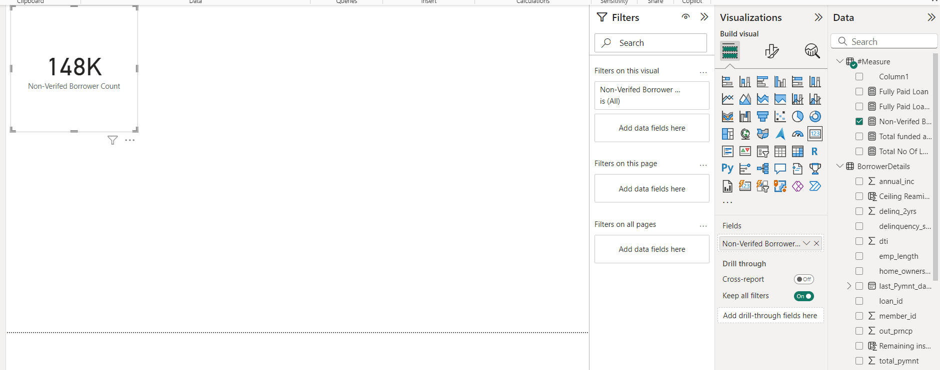

**Create a measure named 'Fully Paid Loan Percentage' to calculate the percentage of fully paid loans. Divide the number of loans with a "Fully Paid" loan status by the total number of loans and then format this measure as Percentage.**



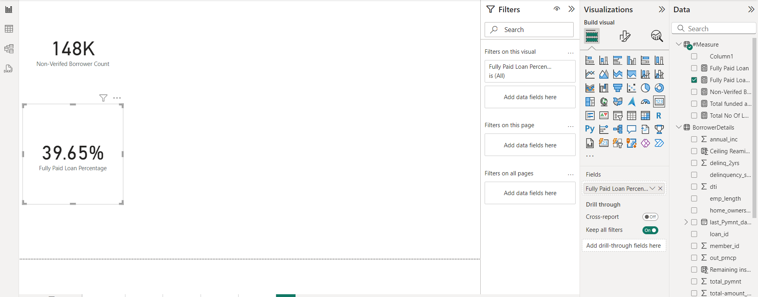

**5) Creating Comprehensive Reports**

**Report 1: Loan Performance Analysis:**

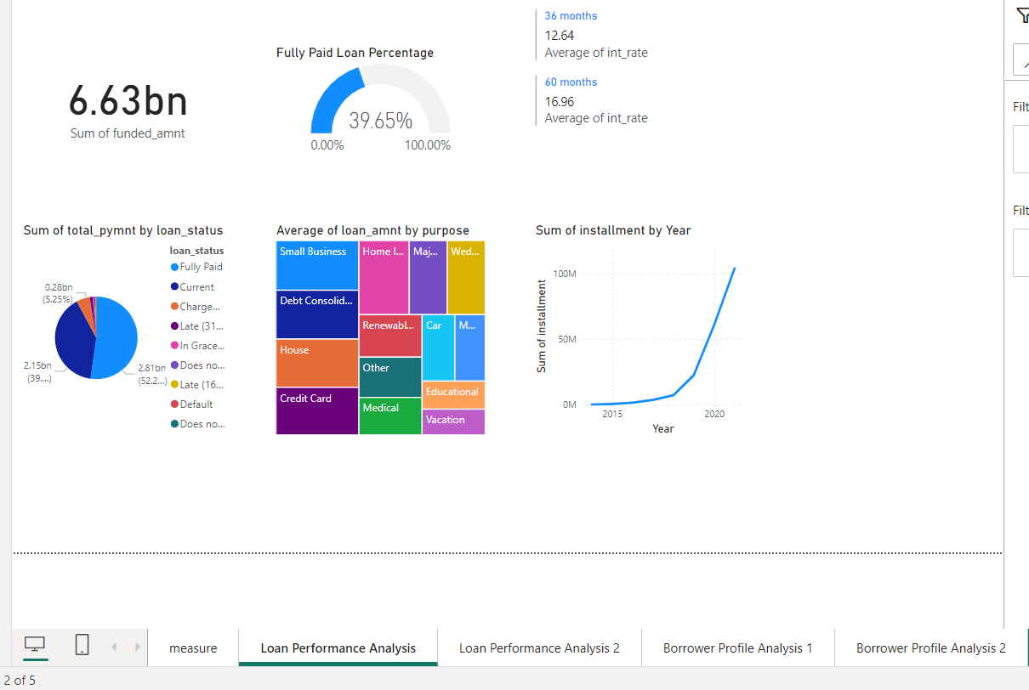

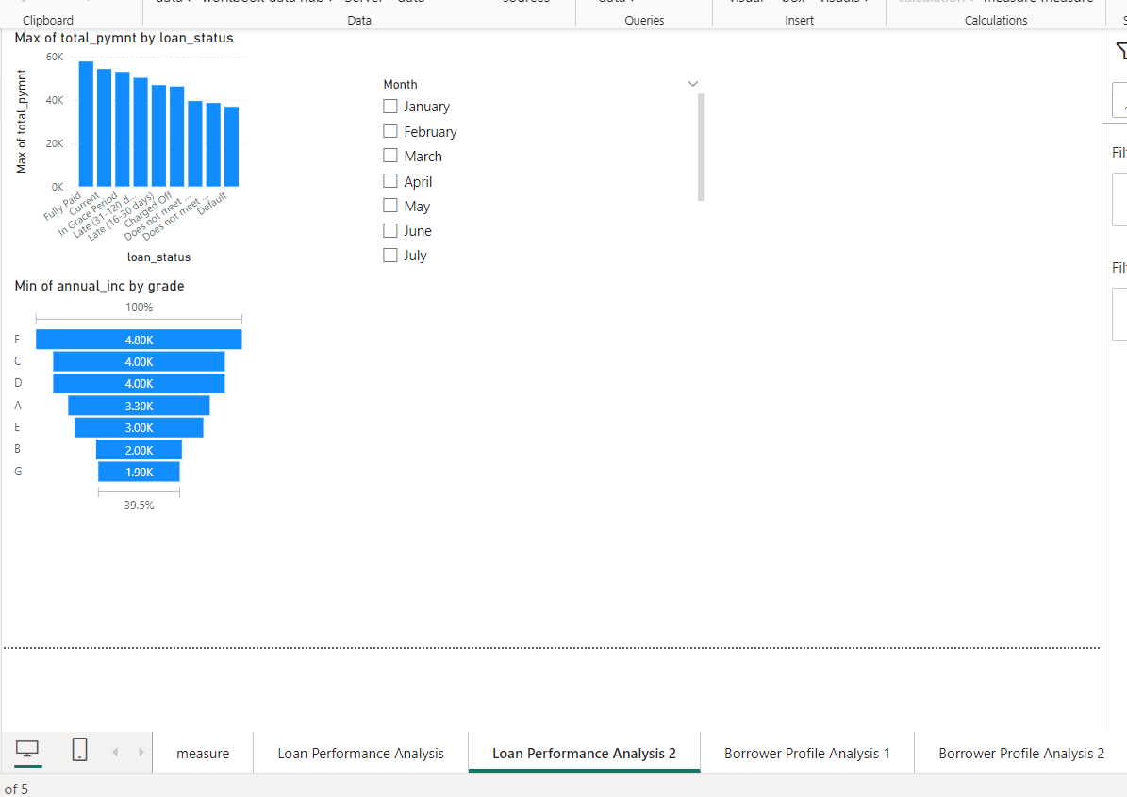

**Report 2: Borrower Profile Analysis**

